History of Howard Community College
Volume IV

1997 through 2007

By
Vladimir G. Marinich
Professor of Social Sciences

TABLE OF CONTENTS
Preface ii
Introduction 1
Changing Of the Guard, for a Short Time 3
A Tough Year Coming Up 8
The Millennium 23
2001: A Year To Remember 30
The Early Part of the New Millennium 35
Camelot? 46
The Last Two Years 50
Legacy 61
Appendix A FY 1998 Organization Chart 64
Appendix B Brochure for Presidential Search 65
Appendix C Presidential Transition Team 67
Appendix D HCC Stakeholders as Identified by the Presidential Transition Team 68
Appendix E HCC Fall Full- and Part-time Credit Enrollment: 1998 - 2006 69
Appendix F HCC Fall Enrollment by Race 70
Appendix G HCC Faculty/Staff by Race 71
Endnotes 72

Preface
This volume of HCC’s history begins with the retirement of HCC’s second president in 1997 and the ten-year tenure of the third president. As in past volumes of HCC’s history, the data that were used consisted of interviews with HCC staff (administrators, faculty), Board members, newspaper articles, Board minutes, official memos, letters, reports, etc. Many of these are in the HCC archive room. The archive is still a work in progress and materials continue to get collected. Many colleagues at HCC have sent me, and continue to send me, old memos, documents, catalogs, and class schedules, etc., that they discover in their files. Some are quite interesting and have historic value. I take them to the archive room almost immediately, and I have communicated my sense of what might be useful to have in the archives to Amy Krug, who is coordinating the archives.

In collecting data on enrollments, demographics, and whatever other quantitative information I might need, I salute my colleagues in the Planning, Research, and Organizational Planning (PROD) Office, especially, and in alphabetic order, Jean Frank, Susan Hellenbrand, Barbara Livieratos (both before and after her retirement), and Betsy See.

A word about the archives. The Howard Community College archives continue to be a work in progress, and a necessary one at that. There are materials in it that go back to the mid-1960’s; that is almost half a century, and that is history! The importance of archival materials can be made from several different points of view. They are simply a record. They may also have historical interest because they help us to understand how and why things evolved as they did at HCC over time. Archival materials can provide us with lessons from the past to help us deal with today and tomorrow. Finally, the materials are artifacts, many of which can be preserved by having them digitized (and then the original can be discarded), but in some cases the artifact has intrinsic value. Consider the letter from the State of Maryland that authorized the creation of HCC, or the first college catalog of 1970, or the very first schedule of credit classes from the same year that was printed on about three mimeographed sheets of paper. These originals warrant preservation.

Professor Stephen Horvath, the Associate Vice President of Academic Affairs, who has authority over the archives, and Ms. Amy Krug, Archives Librarian, have been supportive and have allowed me to help them in organizing materials and in allowing me easy access to the archives.

Dawn Malmberg of the Social Sciences/Teacher Education/Allied Health Office worked absolute magic in getting the various charts and illustrations into this document. Pamela Brown transcribed the interviews and that was no small task.

Professor Ron Roberson, the Vice President of Academic Affairs, who retired in April 2010, our President Dr. Kathleen Hetherington, and HCC’s current Vice President of Academic Affairs Dr. Sharon Pierce have all supported this project. Without their backing, this endeavor would not have been possible. I appreciate their support and I am grateful for it.

I thank all the colleagues that I have named.

Introduction
This volume of HCC’s history deals primarily with the life of the college during the presidential tenure of Dr. Mary Ellen Duncan. She held the office from mid-1998 to mid-2007. It is important for you, the reader, to note that I refer to the life of the college. In working on the history of HCC, I have read the histories of some other community colleges and even a few of four-year schools to get some sense of how histories of educational institutions were written. One of the things that got my attention was the grand approaches that were taken in some of these histories. There were descriptions of the relationships between governmental bodies and the boards of trustees, relationships between boards and presidents, and between presidents and politicians, etc. Legislative issues and budgetary crises were mentioned, but I missed a sense of the spirit of the school or of the culture of the school and how it worked. One might think that there were no students or staff, just governments, boards, and senior administrators. If you are interested in only the loftier issues of state and county and college interaction, you should stop reading now, because my approach attempts to deal more with the kinds of things that bring out HCC’s culture.

I am privileged to have been employed at the college for over 40 years. This is my conclusion: Howard Community College is unique. Howard Community College is a Type-A organization. This is not meant in a pejorative way, rather it is just shorthand for a school where just about everybody is dedicated to the school’s goal of serving students and busily pursues it. And, that dedication is put into action very often. The Board of Trustees and the senior administrative staff set the tone for the college, and the way that this has been done over the years has allowed HCC’s employees to be creative, to be self-starters, and to seek ways in which serving students could be improved. The upshot of this is that many ideas and projects emanated from faculty and staff. There has been relatively little in the way of top-down directives, thereby making the climate at HCC one that promotes faculty and staff initiatives. Some examples of the bottom-up activities include the First Year Experience, the Step-Up program, Freshman Focus, the globalization initiatives by the Social Sciences and English/World Languages divisions, the introduction of Alpha Beta Gamma, the Business Honor Society, publications of HCC’s faculty and administrators, The Muse, which is HCC’s literary journal, and Professor John Bouman’s electronic Economics “textbook.”

On, then, to the college from 1997 to the spring of 2007.

Changing Of the Guard, for a Short Time
Dr. Dwight Burrill’s announcement of his retirement as the second president of HCC was made on July 24, 1997, and was effective the beginning of September. It was a surprise to many employees of the college because it seemed like very short notice. After all, the first president, Dr. Alfred J. Smith, Jr., had given a year’s notice. This did not give the college much time to get a new president. One of the choices was to have one of the senior administrators, such as an academic vice president, operate in an acting capacity while a search was conducted for a permanent president. The Board chose to go with an outside interim president with the proviso that the interim person would not be eligible to apply for the full-time position. One of the reasons given for going outside was so that there might not develop any possible hard feelings among those HCC senior administrators who were not selected. Another reason was that there were many sensitive matters that only the Board was aware of, and the Board concluded that it would not be in anybody’s interest to make an insider’s interim role subject to the issues that were known only to the Board. A third conjecture was that three of the senior administrators did not have doctorates and the fourth who did have a doctorate was relatively new to his Vice Presidency. Thus, the Board decided to seek an outsider. The Board employed a two-pronged approach; one was to contact the American Association of Community Colleges (AACC) and have them search for possible candidates for the interim position. AACC would screen applicants and the Board would conduct the interviews and make the selection. The second and simultaneous action was to start a nationwide search for a full-time, permanent president. Advertisements were placed in newspapers, announcements sent out to educational establishments, and a glossy brochure was developed that accompanied these efforts.

Of the several applicants for the interim position who were screened by AACC, Dr. Linda C. Jolly interviewed well with the Board, and was appointed interim president. One of the things that Dr. Jolly was charged with was not to make any big decisions, but to be a “place keeper.” This created an interesting and problematic situation. So, who was it that was going to make the “big decisions?” Who was in charge?

The situation that the Board found itself in can be explained by the fast transition that was created by Burrill’s announcement in July that he would be leaving by the beginning of September. The consequence of that was that there were some things that were in progress or at issue that required resolution. One such matter was that on July 10, just a bit over two weeks before he announced his departure, Burrill issued a memo to the college community that he was reorganizing the President’s Cabinet. The major changes were that the Vice President of Administration’s job had been changed from being the major financial administrator to “responsibility for plant operations, security, financial aid, HCC Educational Foundation accounting, capital projects, risk management, fixed asset reporting and college inventory.” An individual who had been a consultant to the college on HCC’s hardware/software project called “System 2000” was hired to be the college’s “chief financial officer to assume responsibility for the operations of the business office, the annual audit and for implementing the new financial system on an accelerated time schedule.” Burrill employed another person to be the college comptroller. This organizational change was presented as necessary due to the “critical nature of the system change-over we will be undertaking during the coming year”.

Given just these two matters, and the hiring of a new permanent president, there certainly were other issues; perhaps less critical to the college, but that the Board would have to know and deal with, especially since the interim president was to be in a caretaker role. And, the Board would have to move immediately and quickly on some things, such as getting the search for a permanent president in motion. This they did, so that by early September the process had already begun as mentioned above. The Board felt that it had to be involved in the details of the college’s operation since it was dealing with a temporary president. “The Board members ended up each having a major responsibility within the college.” Thus, the Board entered the realm of micro managing. In addition, within a few months of Burrill’s departure, the Chief Financial Officer and the Comptroller both resigned and their responsibilities were returned to Lynn Coleman, the Vice President/Dean of Administration. The Board was probably busier than at almost any other time. To recap, just consider the entire picture. The president left on short notice, the academic vice president was acting president for about a month between Burrill’s leaving and the interim president’s arrival, the interim president was chosen, a search was on for a permanent president, problems with the computer system, “unorganizing” the recent reorganization, and the need to dig into the details of the college’s operations. All in all, it was not a very enviable situation.

The relationship between the interim president and the Board seemed to function as the Board wanted; that is, to have the president operate in a caretaker mode. The Board’s public minutes for the period between September 1997 through the early summer of 1998 do not show any unusual events or issues. Although what might have gone on in executive sessions is not known, what is known is that in the four months that were left in 1997 the Board met officially at least five times and went into Executive Closed Session each time; somewhat of a record that would continue into 1998.

Henry Linck, who was the Vice President and Dean of Instruction, served as acting president for just a few weeks at most until Dr. Linda Jolly joined the college as interim president in September. By the end of September, the search for a new president was under way. There were 26 members on the search committee and several Board members wanted “more business leaders from the county as part of the committee.”

A major effort was undertaken at this time, too. It was the development of a Presidential Transition Plan. This was a project that had been worked on by Benay Leff, the Vice President /Dean of Institutional Advancement. Leff was certainly the one who would have had the greatest experience in transitions. She had been hired by the first president and was there when he retired, and she was now in the interim phase with a search going on for a permanent president. That makes three changes. A plan was needed, and a draft of such a plan was presented to the Board in December. Leff did quite a job in a short time.

The hubbub of all that had transpired went on during late July through September but really had no effect on the most important part of the life of the college – students. The fall 1997 enrollment of credit students broke 5,000; in more detail, it was 5,081, and most of the other statistics, save one, followed the usual pattern. There were more females than males, the females were older, but the median age of all students stayed about the same. But then, we come to the “Racial/Ethnic Group.” Over the prior two years the percent of minority credit students at HCC went up by about two percentage points, so that by fall, 1997 28½ % of the student body was minority. To borrow from the title of an H.G. Wells science fiction novel, this was “the shape of things to come.”

A Tough Year Coming Up
1998 began on the world scene with both India and Pakistan testing nuclear weapons. In the U.S. the Clinton/Lewinsky scandal made the news, and in more of an entertaining vein, the Denver Broncos beat the Green Bay Packers in the Superbowl, 31-24. The film “Titanic” won the Oscar for best picture, and Celine Dion and Aerosmith were two of the big music names. There were also some who passed away in the early months of ’98: Sonny Bono, Jack Lord (the original McGarrett of “Hawaii Five O”), Dr. Benjamin Spock, and one of the biggest celebrities, Frank Sinatra.

A major event in Columbia was the affiliation of Howard County General Hospital with the Johns Hopkins University’s medical program. This allowed the hospital to provide greater services to Howard County’s growing population and, wisely, “the unique eight-sided architectural pattern of the hospital was designed to allow for expansion,” and indeed, it did.

The spring semester’s enrollments presented no surprises, or maybe just one. Credit enrollments were lower in spring 1998 than fall 1997 but lower enrollments in the spring than in the prior fall had been a general pattern pretty much all along. Comparing spring ’98 to spring ’97, enrollments were up. Perhaps the surprise, or at least something to make note of was the “Racial/Ethnic Group” mix. In spring ’97 there were 68.1% credit students identified as “White.” In fall ’97 it was 66.4%, and in spring ’98 it was 65.9%. So, things seemed to be changing.

By the end of January, the search process for the new president was really moving along.
M. Mattey presented the latest information from the Presidential Search Committee: at the last committee meeting on December 10, 39 of the 65 applicants had received a grade of B or A and their merits were discussed. By the end of the meeting, 12 candidates would be interviewed by the search committee. On January 8-10, the committee interviewed 11 candidates and forwarded 5 names to the board of trustees. The board interviewed the five candidates on January 18 and narrowed the choice down to two finalists. These finalists will be on campus February 16 to meet with the constituency groups.

By early February the Presidential Transition Team was formed. It consisted of 20 individuals who represented every constituent group in the college (see Appendix C). The purpose of this team was to have the new president transition into his/her new role as smoothly as possible and to orient the new president to the college and the community. The plan was quite thorough. It consisted “of five major phases depicted in a flowchart and a table delineating a chronological sequence of nearly 50 proposed events and related action items.” In addition, the team identified 22 groups as “stakeholders” with whom the college should communicate “when planning transition activities.” For the reader’s interest, the list of stakeholders is found in Appendix D.

By February 2, the field of candidates was narrowed to two, and both would be coming to the college on February 16 so that all constituent groups would “have an opportunity to meet the two candidates and offer comments for final selection.” Both candidates had solid experience in higher education and both had backgrounds in community college administration. One of the candidates was the Provost/Vice President of Cuyahoga Community College in Ohio and the other was Dr. Mary Ellen Duncan, President of the State University of New York at Delhi. She also had experience in the Maryland system having worked for a number of years at Catonsville Community College.

On March 3, the decision was made on the selection of HCC’s third president. Dr. Mary Ellen Duncan was appointed to that position. Although Duncan was not to take office until late June, she did establish and maintain contact with the college in terms of getting oriented and planning.

Upon her arrival, these were the members of the college’s Board of Trustees:
Joan I. Athen
Roger N. Caplan
Ronald H. Carlson
Thomas W. McKillip
David A Rakes
Steven W. Sachs
Dr. Frederick A. Schoenbrodt

The senior administrators who were in office at the time of Duncan’s arrival were:
James D. Ball, Dean of Students
Henry Linck, Vice President & Dean of Instruction
Benay C. Leff, Vice President & Dean of Institutional Advancement
Lynn C. Coleman, Vice President and Comptroller

Within the academic area there were 83 full-time faculty, of whom 35 were full professors and 28 were associate professors. Since HCC generally hired faculty at the Instructor and Assistant Professor ranks, and promotions took several years, it is clear that 76% of the faculty had been at the college for a good number of years and were at the two top faculty ranks.

1998 saw the decline of the Summer Honors Program for High School Students. The program had been operating each summer since 1992 and had been attracting high-GPA high school students by offering a true college experience – meaning that such students would take college-level honors courses for credit. One of the unique features of this program was that it was one of very few such programs in the country. The position of the academic area was that this should be a rigorous experience for high school students rather than a summer “baby sitting” one. However, the prior year the enrollment in this program had reached a plateau and it did not seem to be a program that would continue to grow that much in the future. The Admissions Office had proposed that the name of the program should be changed to “Summer Scholars Program” and that there should be some emphasis on “fun.” The result was that the program did not show any major growth, and there was a side effect. Students who signed up for the program would notify instructors that the family would be going on vacation and the student would miss a week or two. For a six-week program, this was not good.

There were other things that had come to the fore. “The Admissions and Advising Office really felt the strain of the increased applicant pools for both Rouse and Freshman Focus which caused the efforts of our office to be concentrated beyond the usual period of time in all respects … choices had to be made and priorities set and we were not able to devote the time to Summer Scholars that we have in the past.” This episode demonstrated two things: one was that both the Admissions and Instructional areas made the mistake of preoccupation for higher enrollment by lessening the academic focus. But the other factor was that the Summer Honors program did not have the priority of Rouse and Freshman Focus, and so, had to get less support.

The fall semester credit enrollment stayed above 5,000; specifically it was 5,100. The two most enrolled transfer programs were Arts & Science and General Studies. The two biggest career programs were Nursing with 508 students and Network Administration with 228. The percentage of minority students dropped a bit to 26% compared to 28% the prior year. Other data seemed to be typical of prior years in terms of female/male ratios, median ages, etc., and telecourses had 885 students, which was not bad for distance learning enrollments.

It was some time during her early months as president that Duncan had meetings with several members of the Board about forming a commission that would consist of a broadly based community representation that could explore the future role of the college. The Board members who were involved were Tom McKillip, Steve Sachs, and Fred A. Schoenbrodt; the latter was most interested in such an idea as “he had seen something like that happen at Gettysburg. He wanted to see something like that [at HCC].”

By October, “the Howard Community College Board of Trustees created a Commission on the Future (COF) to help the College identify emerging issues, prepare for the future, and develop a vision of the College’s role in the 21st Century.” This was no small feat to accomplish, or even to attempt. It required the college to get volunteers from business, the community in general, and college staff to be involved. The result would be an overall strategic plan for Howard Community College. The organization of this commission was seven task forces, each co-chaired by two persons representing some combination of business and community/education. The Task Forces’ charges were:

Creating a World Class Learning Organization
Collaboration with Other Educational Organizations
Collaboration with Business and Industry
Economic and Workforce Development
Preparing Students as Global Citizens
Technology and Education
Communicating with Current and New Markets

In addition to the co-chairs, each task force had between five to eight members who represented some part of the community. Those task forces that dealt more with education had more educators, while those exploring the relationship of the college to the business environment had more business people. The members were carefully selected. Each task force had four representatives from the college as liaison, and these were from administration and faculty. All in all, there were 88 people as Task Force Members plus the Chair of the Commission, Dr. Patrick L. Huddie. Duncan credits Huddie with doing much of the work and there can be little doubt that his efforts resulted in his subsequent appointment to the college’s Board of Trustees. The Commission of the Future, as the reader may note, was a major initiative. It is true that the college always had community outreach and relations as an important part of its mission, but this was really big.

October 22 was the date of Dr. Mary Ellen Duncan’s installation as the third president. The ceremony is worthy of remark. It was held in the Smith Theatre and the audience included HCC personnel, trustees, members of the community, local and state legislators, personnel from other colleges, and a number of Duncan’s friends and former colleagues from colleges where she had worked prior to coming to HCC.
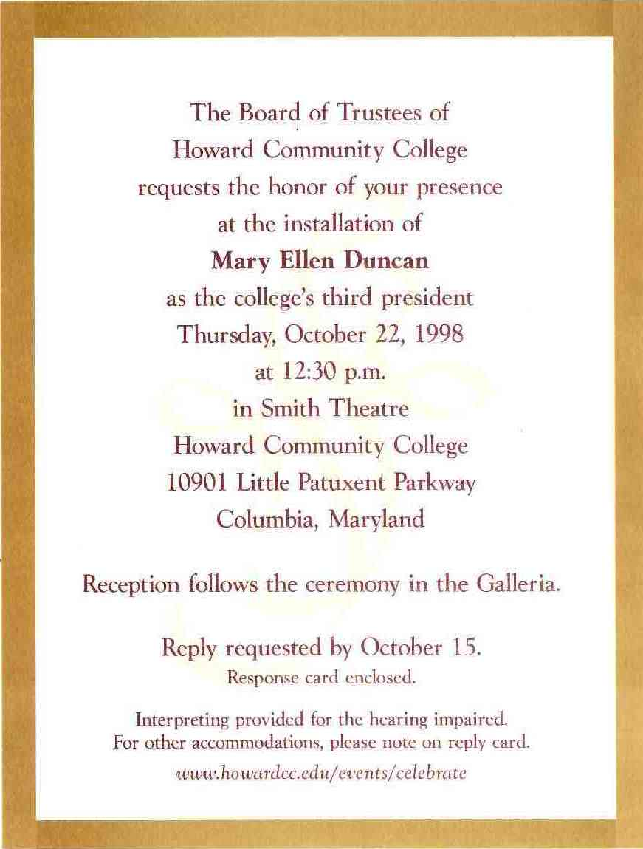

It was a happy occasion, but there still was a bit of trouble in paradise.
As already mentioned, the Board of Trustees had experienced the quick retirement of Burrill, a very short acting presidency by the academic Vice President, about nine months of an interim president, followed by a month of an acting president and finally the arrival of a permanent president. This sequence of personnel changes and this type of interim period certainly suggested that nobody was in charge, so the Board had to get more involved. With each trustee picking up a particular college function, the Board was forced into micromanagement. But, we did mention this before and it is mentioned again for emphasis.

When Duncan began her tenure, the Board continued to require detailed information and control over some of the president’s actions. While this may have been normal for a very short while, it continued for almost 1 ½ years. The relationship between Duncan and the Board became quite strained, so much so, that Duncan seriously wondered if it was worth staying at HCC. The situation began to improve with the support of some of the members of the Board and by Duncan eventually confronting the situation directly and asking, indeed probably challenging, the Board as to whether she could expect their trust and support. That seems to have broken the ice and allowed things to move in a more positive direction.

As 1998 progressed, there were some kudos to be given. Professor Russ Poch of the Science Division was awarded a $10,000 grant “to provide workshops on state-of-the-art techniques for high school astronomy teachers.” Philosophy Professor Dr. Helen Mitchell, who had authored the book, The Roots of Wisdom, and had worked on the development of an introductory philosophy course telecourse, with the college’s TV studio, got the telecourse, “For the Love of Wisdom” nationally syndicated by the Public Broadcasting Corporation (PBS).
Duncan’s First Full Year
As 1999 began, the issue of the Board’s involvement in management of the college continued but Duncan got support from some, especially Board member David Rakes who, as Chair, assisted Duncan with reports and other interactions with the Board to help “avoid land mines.”

The calendar year began as all had in past years. January 1999 was the Winter, or Intersession semester, at HCC with students trying to accrue some credits to take back to the colleges where they were full-time students or by HCC students who wanted to make up credits they were shy in or to accumulate some credits to make subsequent semesters lighter or to complete their programs at the college faster. The winter session was a month long. While the courses were short in time, they went fast and this made them intense. HCC was abuzz; students in credit classes, the Continuing Education Division getting ready for their Winter Credit-Free program, and Admissions and Registration at work on the upcoming spring semester.

The spring enrollment in terms of credit headcount was 53 students less than the prior spring, but it was not a worrisome situation. In the scope of things, it was but a moment and such moments of slight enrollment dips had happened in the past. The college environment was healthy, and a number of changes and initiatives were implemented. The physical environment could use a bit of sprucing up. Much of the landscape between the Nursing/Administration/Theatre Building complex and the Athletic/Physical Fitness Center had been kept natural for years; trees, underbrush, wild plants, and weeds. Duncan had this cleared so that the entire area was more like parkland. This was done to not only give the campus a more attractive appearance, but also as a security measure so that people would be safer going from one part of the campus to another. One of the beautiful results of this project was the contribution made by donors Ginni and Chad Dreier, which was an outdoor octagonal stage with bench seats around it. This venue would be used for outdoor theatrical performances. The stage is named after the Dreiers. The first use of the Dreier Stage that year was HCC’s Student Arts Collective’s full-scale production of Shakespeare’s “A Midsummer Night’s Dream.” The woodlands’ setting for Shakespeare’s play was a perfect choice for the inauguration of the Dreier Stage. The Arts Collective made good use of the stage. It would also present local bands on the Dreier in its series called “Music Under the Moon,” a film series, and Halloween celebrations. The Theatre Department would begin a Shakespeare birthday celebration every April on the Dreier Stage, which would include performances and readings of Shakespeare scenes and poetry. The theatre summer camp program would utilize the Dreier for end- of- camp performances of Shakespeare plays, as well. The stage would also be used for the occasional class on beautiful days. Impromptu performances of guitarists, dancers, actors and singers would be seen on the stage from time to time.

The college now had the Smith Theatre and the Dreier Stage. It also had a Theatre Program, a resident repertory organization, and a student arts collective. As each of these grew there would eventually develop a need for greater facilities. And this would happen several years hence.

The academic side of the house was moving along, too. The Silas Craft Collegians Program was in the planning stage that year. This program was named after Silas E. Craft, Sr. who had been a long time resident and educator in Howard County. He was the first principal of Harriet Tubman High School, which was the first black high school in the county. Craft served a principal from 1949-1956.

The program’s goal was to promote the academic success of recent high school students whose academic performance did “not reflect their true potential.” At its start, which would be the following year, the program would give special emphasis to African American males who tended “to have lower rates of college retention, academic success, and completion.” This program was an important addition to HCC’s responsibility to the community and it got some immediate support in raising funds for scholarships for this program even before the first 23 students arrived in the fall 2000 semester. Board member Roger Caplan pursued a fund raising idea and was able to get the interest and support of a local restaurant to step forward in support of the Silas Craft Program.
On January 10, 2000, the Hunan Manor Restaurant closed its doors from 5:30 to 8:30 p.m. and donated all the food and its employees to raise funds for Howard Community College’s Silas Craft Collegians Program. The event had approximately 500 attendees and the college raised $17,000. The State of Maryland’s Private Donation Incentive Program will match approximately $13,000 of this amount which will bring the total we can add to this scholarship endowment to $30,000!

Other “special” academic programs and courses were moving along well. The Rouse Program was in its 8th year and doing very well. Enrollments were good, Rouse students were transferring easily, and even with preference, to prestigious schools and the best compliment of all was that Montgomery College came to HCC to learn of the Rouse program and to copy it. This they did and their program did well. The only place where Montgomery’s administration of their program differed was that Montgomery established a higher GPA requirement to stay in their Montgomery Scholar Program. Montgomery College’s requirement was 3.2 and HCC’s was 2.5. Back at HCC honors courses that had been offered since the early 1980’s continued to be scheduled, although not as part of any organized program. This would not happen until 2005.

By April 1999 the college had developed a 40-page document entitled “Strategic Vision for the 21st Century.” This was the result of the work that was done by the Commission on the Future. Each Task Force of the Commission identified a number of “strategic process priorities” or, more simply put, goals. These were followed by “tactical action recommendations,” of which there were 73; however, some of the Task Force summaries used a different format, so there really were over 120 items that could be considered recommendations.

The college’s dedication to always looking to improve its performance as an institution was part of the history of the school. In the 70’s there was management by objectives (MBO) for administrative matters and the “systems approach” that specified behavioral objectives that could measure student outcomes. MBO’s morphed into total quality management in the 80’s and early 90’s; however, there was not enough promotion or leadership to allow it to permeate the organization. The issue of measuring the effectiveness of an organization’s activities – in terms of how plans can yield desired outcomes – gained some traction between 1999 and 2001 with the Continuous Quality Improvement Network Trailblazer Program, which was followed in 2002 by the Pacesetter Program. The latter utilized criteria for measuring performance as specified by the nationally known Baldrige Program.

International education became part of the culture at HCC and was promoted in a serious way. While there had been interest in such matters in the past, such as educational and cultural trips abroad since the 1970’s, and courses about the culture and histories of other societies, both in the credit and credit-free areas, 1999 and 2000 was the beginning of an organized effort and emphasis on international and global matters. One of the seven Executive Summaries of the Commission on the Future’s report was titled “Preparing Students as Global Citizens,” and 14 tactical action recommendations were listed. This was just in time because by 2000 over 10% of HCC’s students were foreign born. The college was moving quickly in getting international education under way. HCC joined the Community Colleges for International Development (CCID) and Duncan appointed Professor Rebecca Mihelcic as Director of International Development . The academic vice president, Ronald Roberson, was a strong proponent of international education and a strong force for its implementation. One of his early actions was to establish an international faculty grant of $5,000 a year that would allow HCC’s faculty to travel abroad as an educational experience.

The fall 1999 credit enrollment headcount was up to 5,252. Nursing and Network Administration were still the two big career programs and Arts & Sciences was the big transfer program, and it was the biggest of all with 1,035 declared students. But telecourses began to show a decline. Enrollment in them was down to 712 headcount. This was 172 fewer students than the prior year. Minority group students accounted for 30% of the credit student body. Putting together the foreign born and minority students it becomes evident that the student demographics were changing at HCC. A decade earlier 80% of the student population was “white.” By fall ’99 it was 62%.

The Millennium
As 1999 came to an end of the decade, the century, and the millennium, there was not only the eager anticipation of the number 2000 representing the possibility of progress, peace, and prosperity, but there was also the alarm of technology falling apart. This was the Y2K phenomenon. Many will remember how computer experts and pundits postulated that there was the possibility that systems would not be able to handle the change of several memory bytes that went from year “99” to “00”, and that systems would crash, bank accounts, records of all kinds, and even airplanes might crash – literally. Some religious folk awaited the millennium with joyful anticipation of a second coming while others did so with fearful anxiety. Interestingly and fortunately, none of the above happened and, as far as those who were dependent on computers, it turned out to be no big deal.

The first decade of the 21st century would be considered by many as the digital decade. There were: GPS, IPods, cell phones, and social networks. At the same time, the greening of America also became an idea and an initiative that took hold of society.

Another matter on the national level was the presidential election in November. George W. Bush, Governor of Texas, and his running mate Dick Cheney, were the Republican candidates running against Al Gore, the Vice President of the United States, and Joseph Lieberman, Senator from Connecticut, the Democratic candidates. After major issues and claims regarding votes incorrectly tallied in Florida, the matter went to the U.S. Supreme Court. The court’s resolution gave the election to Bush.

By mid-2000 the population of Howard County was 249,578. There were 10 public high schools, one private high school, and the college received 22% of “recent Howard County public high school graduates.”

Things were really moving along at the college. The planning and development of the Children’s Learning Center (CLC) was under way and it was put in the hands of the Vice President of Student Services, Dr. Kathleen Hetherington, who had joined the college just in the prior year. The CLC was not a “baby sitting service.” While allowing employees and community residents to avail themselves of the CLC, the priority was to serve students with children first. The Center did not offer hourly drop-in service. It was a full year program. In 2000, HCC was going through reaccreditation and, as always, it involved many of the college family and the expenditure of a lot of time on everybody’s part. The thorough and comprehensive work that was done as part of the self-study led to HCC’s reaccreditation. It was also the first time that HCC initiated a capital campaign. The college’s 30th anniversary seemed like a good time to do this and the lack of enough adequate physical facilities made a capital campaign initiative imperative.

The spring semester held few surprises. Credit enrollment was just a touch lower than in spring, 1999. The only notable thing was that the median age of our students, now in the spring, was 24, and this was the lowest so far. But that would change again quite soon.

Faculty involvement in educational and professional matters is worthy of remark. Two examples of faculty commitment to their students stand out in 2000. Philosophy Professor Helen Mitchell, working with her husband Joe Mitchell, saw the second edition of their reader, Taking Sides: Clashing Views in World History, published and the first edition of their reader, Taking Sides: Clashing Views in Western Civilization, also published in the same year. Numerous colleges, including the Military Academy at West Point, adopted these texts. Another important contribution was economics Professor John Bouman’s initiative in digitizing his economics courses. Bouman had been developing his own “textbook” for several years in an attempt to move away from costly published texts. By 2000, he was able to put all his materials, narratives, exercises, quizzes, charts, graphs, etc. on a CD. He now had a CD as his textbook. As the cost of textbooks kept going up and up to prices of around $100, Bouman’s CD cost the student about $25. Bouman was certainly helping the students.

HCC’s physical appearance was seeing some change. The gymnasium of the Athletic and Fitness Center was getting a face-lift. The new floor of the gym would be made of “a composite of wood and synthetic materials that will improve the overall appearance of the facility to provide better playing conditions for the athletes. The HCC name and crest will be imbedded into the floor using school colors to create a sense of identification and recognition for players and spectators.”

Commencement was on May 18 and, as it had been for a few years now, it was at the Merriweather Post Pavilion. There were 316 graduates across 13 programs: 225 graduates in transfer programs and 91 in career programs. The guest speaker was Dr. Benjamin Carson, Director of Pediatric Neurosurgery at Johns Hopkins. In addition to his medical qualifications and expertise, he was also quite the motivational speaker. And he was a celebrity, having written the book, Gifted Hands, and having received the Presidential Medal of Freedom. He was also very much in demand; so the college was fortunate to get him as the speaker.

One might think that summers on a college campus tend to be more relaxed, operate at a slower pace, and are spent in reflection and planning for an upcoming year. As the college’s track record shows, that was not the case at HCC. Certainly, reflection and planning are a necessary part of college activities, but there were summer courses in both the credit and non-credit areas and new programs that were getting their finishing touches in anticipation of starting up in the fall. The Emergency Medical Technician/Paramedic Program was in operation by the summer, and the Silas Craft Collegian Program was revving up for the fall. The Social Sciences Division was putting its finishing touches to two new tracks in its AA offerings: American Studies and International Studies. Both would appear in the 2000-2001 college catalog. And, lest it be forgotten, the Development Office was into the near final stages of getting ready for the 13th Columbia Classic Grand Prix that would be held on Saturday, September 23.

Summer session was the time that county students who had gone to other colleges were home and either had to make up credits or wanted to rack up some credits, whether it was to take back those credits to their colleges or, if they were HCC students, to do likewise. Summer session 2000 was organized the same way that past summers were. There were two “semesters;” Summer 1 and Summer 2. The first went from May 30 to July 3, and the second was from July 5 to August 8. Each was five weeks long, one right after the other. The courses that were scheduled would be several hours a day, four days a week. This was heavy duty, but the summer sessions had been growing for several years and this would be the last time that the college would have just two sessions. Things would be different the following year.

By 2000 the college had over 20,000 students; almost 8,000 credit students and over 12,000 non-credit brought in by the Continuing Education Division.

The Grand Prix equestrian event that was held in September netted $140,000. Since its beginning in 1988 the Grand Prix had netted almost $1.25 million. There were other fund raising events that year. One was a river cruise in Russia. Barbara Livieratos, the Associate Director of the PROD office planned the trip as a way of raising money for a scholarship fund in memory of her late husband. She was assisted in this effort by the author. Thirty-five community residents went on this cruise from Moscow to St. Petersburg, and several thousand dollars were accrued for the scholarship fund. There would be four more such annual cruise trips to Russia.

Just by way of review, the results of many of the 2000 initiatives occurred in the fall. The gym floor was ready by the start of the fall semester. The first Silas Craft cohort of 24 students began the fall semester. The 13th Columbia Classic Grand Prix was held on Saturday, September 23. The CLC opened in October, and the Middle States Evaluation Team was on campus from October 22 through 25. Now, that is an active campus! Let us not forget student enrollment in the fall. The college was at 5,452 in credit headcount, minority students still accounted for almost 30% of the credit student body, and the median age of the college’s credit students in the fall dropped to 23. For about the prior 5 years the median age had been dropping by one year each year. In 1995, the median age had been 28. The number of students enrolling in telecourses was declining. In fall 2000, there were 651 students, down by several hundred from just a few years earlier, but there were 593 students enrolled in online courses that semester. Technology was on the move with one distance learning approach replacing an older one. Change was continuing!

2001: A Year To Remember
As always at HCC, the year began with lots of activity. The winter session of credit classes started on January 2 and went to January 29. While the classrooms were busy, in another part of the school, January 20 was the Showcase of the Arts. This was a day of workshops, demonstrations, and other artistic experiences for the community. It was followed in the evening with a fundraiser that “was an evening of dance, music, and theatre, all performed by HCC faculty and friends.” Rep Stage, the college’s theatre artists in residence, celebrated its eighth year.

The spring semester of credit classes began on January 29. This was the first time that the spring semester reached a credit headcount over 5,000. The actual number was 5,269. The schedule of classes listed 65 on-line courses; 19 more than the previous year.

May 17, 2001, was the 30th Commencement of the college and the guest speaker was Donald Graham, Chairman and CEO of The Washington Post. There were 329 graduates: 238 in transfer programs and 91 in career programs. This was also the first year that the college awarded honorary degrees. The first recipients were Leola Dorsey and Celonia Walden. Both had been on the college’s board of trustees and even after their tenures as board members, they continued as very dedicated friends and supporters of HCC.
The “First Year Experience” Program was initiated in the spring of 2001. The background to this was that the faculty of the retention committee were frustrated with new students who were unprepared for college work and college life in general. A contingent of the college’s retention committee attended a conference at the University of South Carolina that had developed a first-year course for their entering freshmen. The result was that HCC adapted the ideas and introduced First Year Experience (FYE) at HCC in the fall. The program taught faculty better ways to communicate with students and better to understand what student success might mean. The program would be based on communication and the development of closer relationships between the faculty, Student Services, and students. Over the next few years there would be “campus-wide discussion of a holistic definition of student success.” As a result, of the “ranked ten most important components of student success,” only three were pedagogical in nature and in the following two years a “Faculty Learning Community” was established for “promoting deeper faculty understanding of successful strategies appropriate for first-year students.”

As summer rolled in, construction on the Instructional Laboratory Building began in June. The project would take over a year and the building, which was to become known as the ILB for a short time, would be ready for use in January 2003.

HCC also expanded to the south by opening the Laurel College Center. The Laurel College Center, “a partnership between Prince George’s Community College and Howard Community College opened its doors in 2001.” The Laurel Center was close to the border between the two counties and could benefit potential students from both counties to have access to education closer to home or work. The chair of HCC’s Board of Trustees stated that there were “a lot of possibilities with a presence there. There are 130,000 people living within 10 miles of the building.” This would become an important satellite location of HCC as well as a partnership that would eventually include other colleges and universities. On campus, the summer session of credit classes saw a major change from prior years. It was no longer two sessions. The new arrangement was four different schedules. These were:
Summer 1 5 weeks (May 29 – July 2)
Summer 1 (extended) 8 weeks (May 29 – July 23)
Summer 2 (extended) 8 weeks (June 13 – August 8)
Summer 3 5 weeks (July 5 – August 8)

The prior year, when there were but two summer sessions, the number of credit students enrolled was 2,239. Now, in 2001, with multiple sessions, the numbers came out as follows:
Summer 1 989
Summer 1 (Extended) 449
Summer 2 (Extended) 193
Summer 3 841
TOTAL 2,472

The decision to modify and extend the summer schedule paid off. Indeed, the following year the summer enrollment would be higher still, at 2,721. Summers were not quiet and placid at HCC.

The fall semester of credit classes began on Monday, August 27. The credit headcount was 5,934. We were close to breaking 6,000, and that would happen soon enough. Eighty-seven percent of HCC’s students were Howard Countians and their tuition was $81 a credit with a $10.53 consolidated fee per credit. An in-county student carrying 15 credits paid $1,215 plus $157.95 consolidated fees. An out-of-county student’s price tag was about twice that amount.

Within two weeks of the start of the fall semester, 9/11 struck the United States! It was the first attack on U.S. territory since Pearl Harbor, and it was the first attack on U.S. soil since the War of 1812! Students and staff who had heard that something happened and immediately began watching on TVs around the campus, the first thought was that it was a terrible accident. But the next few minutes brought a sense of terror to all who watched and saw the second plane, and heard that something similar had happened at the Pentagon in Washington, D.C., that the full realization hit everybody. The event was stunning. The students and staff organized a remembrance program on Thursday, September 20. An important role in organizing the event was played by the president of the Student Government Association, Neetika Sharma. The program included international students who spoke of their appreciation to be in the United States, singing of patriotic songs, and the SGA handed out American flags to those who attended.

The life of the college not only moved on, but it also got support from the community. Barbara Schulte had been on the Howard Community College Educational Foundation since 2000, and in November 2001 she and her husband Jim, donated $10,000 for a travel abroad scholarship for which HCC students could apply. The application could be for study abroad, such as a winter or summer session, or it could be used for travel with an educational component that included the student submitting a report or journal to be approved by a faculty member.

The Early Part of the New Millennium
The spring semester of 2002 began on January 28. HCC was continuing to grow. The spring credit enrollment was 5,633 and that was 364 students more than the prior spring. The schedule of classes was still being published in newspaper tabloid form and it was 60 pages long. In addition to all the standard-format classes there were more courses using technology. A sizable part of an entire page in the schedule listed 59 online courses, 13 telecourses, 5 teleweb, 8 campus-web, and 4 interactive courses. The latter were courses conducted in the interactive classroom in partnership with Harford Community College. Students of both “HCC’s” were in their respective schools’ classrooms and were in real life visual contact with the instructor at this (Howard) HCC.

As construction on the Instructional Laboratory Building was progressing, a time capsule was placed into one of the pillars in front of what would be the entrance to the building. The capsule was placed on April 18, and it was to be opened in 2052.

HCC’s continued commitment to being more international and to valuing diversity showed itself in a number of different ways. Throughout the year, the college had established and maintained contact with colleges and universities from Denmark, Japan, and Turkey and worked out ways to have student exchanges, faculty visits, and exchange visits by administrative personnel. The Director of Admissions, Barbara Greenfeld, visited South Korea and was able to interest potential students in coming to HCC. The college’s Continuing Education division responded to companies in the area that had Hispanic employees by offering Command Spanish, which was a basic course that taught generic phrases for supervisors of Spanish-speaking employees. At about the same time, HCC offered “English for Speakers of Other languages for Families.” The course was oriented to children and parents. It was an unusual first!

Not all the activities in HCC’s commitment to international education and interactions were grand initiatives; some were small steps, but meaningful ones. A dramatic and charming demonstration of HCC’s dedication to diversity was the May 23 Commencement. This was the first time that international flags were carried by HCC staff and students at an HCC commencement as a way of celebrating HCC’s heterogeneous student body, which represented 70 different countries. After the commencement festivities were over, the flags were hung on display in the Burrill Galleria, and a world map was put on display in the first floor hallway of the Clark Building with pins for every country that had students at HCC. It was a modest-sized map, but quite impressive!

By fall, the county added another high school – Reservoir High School. This brought the county up to 11 public high schools and one private high school. At HCC, the student credit enrollments went over 6,000 – 6,182 to be exact. The median age of the students was 22 and the minority proportion of all credit students was 32%. Our students were getting younger and of the 32% who were members of a minority, the two predominant groups were African American with 19% and Asian with 10%. Hispanic students accounted for 3%, which had been a steady percentage for the past four years.

The year 2003 began with the opening of a new classroom building. There was a ribbon-cutting ceremony held on January 23 to inaugurate the Instructional Laboratory Building (ILB) officially. Classes began in ILB for the spring semester on January 27. It was “a 105,000 gross square foot facility and (was) the first new instructional building on our campus since 1989.” There would be “upwards of 63,000 square feet of usable classroom space that will accommodate growing student numbers in both classroom and laboratory settings.” The building was described as one that amazed visitors as being “so attractive, with large sweeping windows, a breath-taking 3-story atrium, classy wood accents, and colorful hues expertly coordinated in the wall colors, carpet, and furniture.” Classes could now be moved out of temporary portable trailers and into ILB. There was one more very important feature that the addition of the ILB contributed. Its location next to the Library Building (subsequently named the Clark Library) and across from the nursing and administration buildings created a quad. This made all the difference. HCC was really beginning to look like a college, and that counts!

Faculty offices and various classrooms that had been in other buildings were moved to the ILB. One such specific program that moved from the Library Building to ILB was the Office Technology Program that operated under Professor Judy Law. This move freed an area of approximately 2500 square feet on the second floor adjacent to the college’s library. Within a very short time, in March, that area had a new tenant. Some time before, Duncan had visited the Howard County Center of African American Culture that was headquartered in downtown Columbia. This Center consisted of both a museum and a library. During her visit, Duncan noticed how overcrowded the place was and she offered to help. The library portion of the Center moved into the vacated area at HCC in September. In addition to the generous gesture made by Duncan, the rationale to have the Howard County Center of African American Culture (HCCAAC) Research Library on campus was to allow HCC students to have access to the library’s resources, since keeping the library at its Vantage Point Road location would require students to go there. HCC continued its commitment to diversity by acting on this commitment.

And speaking of celebrating diversity, travel and study abroad programs were growing at a fast pace. Seven trips were planned during the year, and six went: China, Costa Rica, France, Greece, Italy, and Mexico. The annual fund-raising trip to Russia would have been the fourth, but was cancelled due to a State Department advisory that travelers should be cautious due to the SARS epidemic and the U.S.’s invasion of Iraq earlier in March, but there would be one the following year.

It was also the year of awards and top-notch performances. On March 3, HCC received the Bronze Maryland Quality Award. This award was part of a statewide program sponsored by the University of Maryland Center for Quality and Productivity and it was tied in with the U.S. Senate Productivity Program. Both of Maryland’s U.S. Senators, Barbara Mikulski and Paul Sarbanes attended the awards event. The National Academic Advising Association honored HCC with the 2003 Outstanding Institutional Advising Program Award for the college’s Freshman Focus Program. Rep Stage continued to increase its reputation of quality productions and performances. By 2003, “Rep Stage has earned 28 Helen Hayes nominations in its 10-year history and has won five.”

HCC’s athletic programs were really on the rise. Under the Director of Athletics, Diane Schumacher, the Athletic and Fitness Office Manager, Mary Kay Casciaro, and the leaders of athletic operations, Stephen Musselman and Katherine Seagroves, the Fitness Center operated at peak capacity and HCC’s teams fared much better than just well. The women’s soccer team truly did well. Coach Kate Seagroves “led her team to a 15-3 record, and a number 1 ranking in the National Junior College Athletic Association (NJCAA). The men’s soccer team “finished the regular season undefeated, 17-0 … and were the Region 20 champions.”

HCC’s success, especially in athletics, is understandable. As the college grew and as its reputation did the same, HCC’s athletic programs began to draw some of Howard County’s high school star student athletes who would not only raise HCC’s competitive place in NJCAA, but would also get the college’s teams into Division III championships. But it was not just soccer. HCC’s cross-country, volleyball, and basketball teams also drew top student athletes who, after being at HCC for two years, went on to four-year schools, often with athletic scholarships.

After many discussions, the college and the Soccer Association of Columbia (SAC) entered into an agreement where the two sides would share the costs of maintaining and using several of the athletic fields for a 15-year period. This certainly added to HCC’s reputation as a community-minded institution, especially since soccer was a very important sport in the county and it was recognized as being a soccer powerhouse regionally.

HCC’s continuing interest in being accountable to its various stakeholders led to exploration of some programs that had shown success in measuring an institution’s performance. Several members of HCC’s staff attended a presentation in Baltimore on a program called CitiStats. The philosophy of the program seemed like something that could work at the college, although there were changes that would have to be made since Citistats was developed for municipal use by Mayor Martin O’Malley. Thus was born “Vital Signs,” the thrust of which was to have a system that could monitor HCC’s effectiveness at every level of departmental activity. Each level in the organization would establish a set of measures with which to track the performance and accomplishment of an institutional unit. Further, it would be the Board’s responsibility to establish major institutional goals from which the various unit-level measures would be established. Several years later, when Governor O’Malley and County Executive Ken Ulman visited the college to see a presentation of HCC’s Vital Signs, the governor praised the college’s efforts and commitment to “Vital Signs.”

During spring 2004, there were some initial meetings and planning for the Step Up Program. Step Up was unique. “Students who volunteer to participate in Step UP are paired with a faculty or staff coach who provides one-on-one support for managing the challenges of college. There are no agendas or set goals; instead, students are encouraged to question, share, and explore ideas with a caring listener.” To get things going meant that the program would have to be explained to the HCC community, volunteers who wanted to be mentors to students had to be trained, and the program would have to be put in place and begin operations. After almost a year-and-a-half of researching and planning, the Step Up Program was put into operation. The first part of the program was to get college personnel, whether staff, faculty, or administrators, trained as coaches. This is important to note because this was not a faculty-to-student relationship that was to be developed but a person-to-person one and it was college-wide. One’s occupational position in the college was not important, but a coach had to be willing and desire to connect with students and provide a very human mentoring relationship that was not strictly academic. Employee participants ranged from the college president to Plant Operations staff. That is commitment!

Step Up’s first attempt was a modest pilot effort, with 15 students paired with fifteen trained mentors. The results tended to be inconclusive, but the basic philosophy of the program was so compelling that the college and the coordinators were determined that it could and would succeed. The following years proved them correct.

As the 2003-2004 academic year began its fall semester, there seemed to be no end to HCC’s ability to have an adventure. The Grand Prix was scheduled for Saturday, September 20. It had to be rescheduled because Hurricane Isabel was coming through the state. “Not even a hurricane can stop the Columbia Classic Grand Prix from taking place.” Fortunately, Sunday the 21st was clear and the event came off without a hitch, and netted $140,000. Not bad.

So, the year came to an end with over 6,400 credit students, the college kept growing, the college had added a beautiful classroom building, and thanks to major donations from Peter and Elizabeth Horowitz and the Rouse Company, a new visual and performing arts building was in the offing.

HCC’s history professor and chair of the Social Sciences Division, Dr. Jerrold Casway, was both a published expert and author in the area of 16th and 17th century Ireland and he also was an expert in the early days of American baseball. His research on this period of baseball led to the publication of his biography on one of the early baseball celebrities. The book was, Ed Delahanty in the Emerald Age of Baseball, published by the University of Notre Dame Press.

A new honors program came into planning in 2004. There was, of course, the Alpha Alpha Sigma Chapter of the national two-year college honors society. HCC had been a member for at least two decades already, and there was the Rouse Scholars Program that was a cohort program solely for recent high school graduates. The Director of the Admissions Office, Barbara Greenfeld, recommended that the college develop an organized honors program because the Rouse program’s restriction to students who had just graduated from high school did not allow any other students to participate in honors education. A committee met in October to discuss and establish some preliminary plans for an honors program that would serve a wider population of students and that would include part-time students, evening students, and “adult” students. The basic requirement for a student to get into the program and to stay in the program was a 3.2 GPA.

Once there was consensus that such an honors program should be developed, the questions came up as to how it should be organized, administered, and what it should be called. A number of scheduling models were developed, some quite structured, but under the academic vice president Ron Roberson’s leadership, it was agreed that given the heterogeneity of the students, the program had to have the scheduling flexibility to accommodate students who worked, had family responsibilities, or could take only a limited number of credits in any semester. The GPA requirement would stand since this would be an honors program.

By early 2005, the general organization of the program was set. The start of the program would be in fall 2005, and the program needed a name. At a meeting to choose the name of the program were Greenfeld, the Academic Vice President Ron Roberson, several Chairs, and Professor Vladimir Marinich, who had been coordinating and scheduling honors courses in the past. A number of different names were brought up, some of historic Maryland and Howard County individuals. Marinich recommended that the program be named after one of the individuals who was instrumental in the creation of the college – Frederick K. Schoenbrodt. Marinich presented Schoenbrodt’s biography at the meeting and the group accepted the proposal, and Roberson, whose professional background was as an artist and art professor, designed the logo for the Frederick K. Schoenbrodt Honors Program.


The Frederick K. Schoenbrodt Honors Program was put into operation, on time, in fall 2005. The schedule of credit courses listed eight courses and eight seminars under “Honors,” The courses included English, history, philosophy, psychology and sociology. The seminars were in biology, chemistry, and mathematics.

Camelot?
Belmont is beautiful! It is idyllic! It is a historic site. Anyone would give their right arm to own it; but just like Camelot of Arthurian legend, circumstances surrounding Belmont would present problems. The early history of Belmont can be found, with some searching, in various books on Howard County and newspaper reports especially during the several times that the estate was for sale. Here is a short chronology for the reader. Belmont was built somewhere between 1735 and 1738 (different writers give somewhat different dates). More importantly, one Caleb Dorsey who operated an iron business in the area constructed it in the early part of the 18th century. His estate was approximately 1,300 acres. More recently, in the 20th century, David K.E.Bruce, an aristocratic Baltimore-born individual who served as U.S. Ambassador to West Germany, France, and the United Kingdom, had owned Belmont. In 1964, he “sold the estate to the Smithsonian Institution for $500,000, a gift to the Institution from an anonymous donor.” Then, in 1983, the Smithsonian sold it to the American Chemical Society and to the State of Maryland. The property at this time was an approximately 369-acre estate in Elkridge and included a Manor House, the Dobbin House, and a Carriage House.

The Smithsonian’s reason for selling the property was that it was losing money operating it as a conference center. While the following might not have been a reason for the Smithsonian’s putting the property up for sale, it certainly was a complicated situation. There were several organizations involved with Belmont in one way or another: the National Trust for Historic Preservation, the Maryland Historical Trust, the Maryland Department of Natural Resources, the Historic District Council for Ellicott City, the offices of Congresswoman Beverly Byron, and State Senator James Clark. And then, there also were the residents of Belmont Woods Road in Elkridge. Their concern was that the one-lane road, about a mile long could create problems. In addition, there was more than one potential buyer for the property and the residents questioned the background of one of the possible buyers as not being prepared to run a country inn, and preservationists “were afraid a developer would buy it and ruin the character of the early eighteenth century manor house.”

As early as 1980, the Maryland State Department of Natural Resources, upon hearing that the Smithsonian was thinking of selling Belmont, entered into discussions with the Smithsonian. Soon a few more potential buyers appeared on the scene. Of the several bidders, the sale finally went to the State of Maryland and the American Chemical Society. The former purchased “294 acres for the Patapsco Valley State Park,” for about $2 million and The American Chemical Society purchased about 82 acres that included the buildings mentioned above for $780,000.

The American Chemical Society owned Belmont from 1983 to 2004. It used the facilities for retreats, conferences, and catering to outside organizations. By June 2004, it was reported that the American Chemical Society was putting Belmont up for sale because the facility “lacks adequate meeting space for their needs,” however, HCC knew about the Society’s plan to sell Belmont at least as early as May, and probably earlier. “The Foundation is pursuing purchasing the Belmont Conference Center. The purchase would include twenty eight (sic) acres of land that could be used for educational, or other, purposes.” By June 15, “M. Duncan stated that the Foundation has started the process of purchasing Belmont Conference Center. M. Duncan said that the plan is to continue with the current business in place and an educational piece, perhaps a culinary school and hospitality program,” and by September “. . . the board approved the . . . resolution to purchase the Belmont Conference Center,” and less than two months later “HCCEF acquired the Belmont Conference Center.”

HCC’s purchase of Belmont required the college to work with various organizations and agencies, some of which have been mentioned above. There were also county zoning and licensing matters, as well as the concerns of Elkridge residents. Duncan and members of her staff had to work with the community, and that proved difficult. As an example, “. . . the transfer of the liquor license was successful. The neighbors tried to intercede by appealing and trying to find discrepancies in the application.” This was but one of many actions in opposition to the college’s activities in its ownership of Belmont. There were arguments presented objecting to any possible acquisition of part of the property by a builder, concerns about increased traffic, etc. Almost every effort on the part of HCC to repair, remodel, or improve the property was seen as a precedent for further changes that the residents saw as a threat to Belmont and to their own property rights and values. The residents organized. “A group of Elkridge residents has formed the Save Belmont Coalition ‘to preserve the vision established by the Smithsonian Institute (sic) for the historic tradition and economic viability of Belmont.’”

While Belmont was so full of possibilities, the challenges of negotiating and living with all the state, county, and historic trust regulations, and the concerns of residents of the area were daunting. Not the least of things was that Belmont would have to continue to pay for itself through conferences, catering, and various other paid events, and a recession was looming on the horizon.

The Last Two Years
In 2005 the college’s athletic fields had been in need of renovation for some time. The track was almost 35 years old, the soccer fields were uneven, and time had simply taken its toll on the area. Work had been in progress on the various parts of the outside facilities for over a year to get them in shape, and “on April 22, 2005, the college’s new soccer, lacrosse and track fields were dedicated.” And speaking of athletic matters, a number of HCC’s teams really shined. The men’s cross-country team won its third Junior College Conference and tenth Region XX championship. The women’s volleyball team won its second straight championship in Region XX finals, and the women’s soccer team won its second Region XX championship by defeating the much bigger Montgomery College. HCC’s athletic programs had definitely come of age and were on a roll.

HCC’s ongoing interest in pursuit of quality improvement naturally led to getting involved in the Malcolm Baldridge National Quality Award Program. The program’s main criteria are to “help organizations assess their improvement efforts, diagnose their overall performance management system, and identify their strengths and opportunities for improvement.” This meant that HCC spent considerable time and effort in applying for the award, which no community college at that time had ever won. The collection of all the data from student and employee surveys, faculty and staff accomplishments, unit achievements and, finally, the nature of the application process itself, were all massive efforts that were mainly the responsibility of the Planning, Research, and Organizational Development (PROD) Office. It was important to stay focused on the reason that the college was getting involved in such a project, lest it become the quest for some plaque or bragging rights.
Duncan emphasized that the main interest of the college in submitting the Baldridge application was to receive feedback for self-improvement – not necessarily winning the award.

By fall the county had added another high school. There were now 12 high schools – Marriotts Ridge on Route 99 being the latest. The fall 2005 semester at HCC began with 6,841 credit students. As in the past there were over a thousand more female than male students, the median age was 22, minorities accounted for 38% of the student body, and over the past five years, the proportion of out-of-county students had grown from 11% to 15%. Arts and Sciences and the General Studies programs were still the two biggest of the transfer programs, but now the Nursing/LPN Pathway program was in third place with 875 students. All the health sciences programs combined, both transfer and career, added up to 1,127 students. These career fields were in demand and were growing.

In October 2005, as part of the 35th anniversary of the college, there were panel presentations by some of the original faculty on their recollections of the early years of HCC. There also was a panel of past members of the Board of Trustees and their recollections, not only of the early years of the college, but also of the 1960’s decade, prior to the college’s existence, when discussions and plans for a community college were being developed.

The celebration continued into the first several months of 2006. The college initiated a major celebration titled “Alumni and Friends Reunion,” which was held on Saturday, May 20. The festivities lasted from 3 P.M. to 8 P.M., and included art exhibits, dance and theatre performances, videos and slide shows of the first years, a reception and dinner, and a tour of the college facilities and buildings for those alumni who had not been to the college in many years and had not seen how the college had grown. A week later, on May 26, HCC held the groundbreaking ceremony for the new student services building, the Rouse Company Foundation Student Services Hall.

Some of the national and local events of 2006 are presented here simply as a frame of reference for the reader. The news media brought several deaths to the world’s attention. Former President Gerald Ford passed away at age 93. Iraq’s ex-dictator, Saddam Hussein was executed after three years in captivity and conviction of crimes against humanity. The “godfather of soul,” James Brown, died at age 73, and Betty Friedan, the author of The Feminine Mystique, passed away at 85.

Some of the elections at the end of the year proved to be quite interesting. The November elections produced some major changes in the United States. At the national level, the Democrats retook both the House and the Senate, and many interpreted this as a repudiation of President Bush’s Iraq involvement. At the state level, Maryland elected Ben Cardin to the U.S. Senate seat vacated by the retirement of Paul Sarbanes. Cardin defeated his Republican opponent, Michael Steele, who was the Lieutenant Governor. Martin O’Malley, the Mayor of Baltimore defeated Republican Governor Robert Ehrlich for the Governor’s job. Another sweep for the Democrats.

In Howard County, Democratic County Council member Ken Ulman defeated his Republican colleague for the County Executive position, and Jim Robey, who had served two terms as Howard County’s Executive, ran for Maryland State Senator, and defeated the Republican incumbent, Sandy Schrader.

At HCC, the 2006-2007 academic year was Duncan’s last as president. But it certainly was not one where she took it easy and coasted toward retirement. The number of credit students enrolled in fall 2006 semester broke the 7,000 mark with a credit headcount of 7,161. The place was growing. In addition, the demographics continued to change. The college had more African American, Asian, and Hispanic students. Cumulatively minority students continued to account for 38% of the credit student population, and the proportion of out-of-county students had risen from 15% the previous year to 17%.

The president’s relationship with the Board that had started with some tension and friction had become a close, effective, and a good one over the years and this can help to explain the success that HCC had as an educational leader and a true presence in the community.

In this, her last year, Duncan worked with the following members of the college’s Board of Trustees:
Dr. Patrick L. Huddie, Chair
Mr. T. James Truby, Vice chair
Ms. Roberta Dillow
Mr. Roger N. Caplan
Ms. Katherine K. Rensin
Mr. Louis G. Hutt, Jr.
Ms. Mary B. Tung

The Howard County governmental leaders that Duncan worked with were mainly the Howard County Executive and the Howard County Council. The Executive was James N. Robey. He had been a community college student himself, and he was very sympathetic to the goals of HCC and the challenges that Howard Community College faced. In short, he was supportive of the school. The members of the County Council were:
Dr. Calvin Ball
Mr. Charles C. Feaga
Mr. Guy J. Guzzone
Mr. Christopher J. Merdon
Mr. Ken Ulman

The relationship between the Council and the college during Duncan’s tenure as president was positive for the most part, and if there were any areas of disagreement, they were minor.

The members of Duncan’s immediate staff, the president’s team, were the administrators and staff of the major functional units of the college. They were:
Lynn Coleman Vice President of Administration & Finance
Thomas Glaser Vice President of Information Technology
Farida Guzdar Executive Assistant to the President
Dr. Kathleen Hetherington Executive Vice President/ Capital Campaign Manager
Zoe Irvin Executive Director of Planning, Research, and Organizational Development
Ronald Roberson Vice President of Academic Affairs
Erin Yun Director of Board relations/Special Projects

The president’s team was very experienced, each member having years of prior managerial or staff service at HCC or elsewhere. Thus, the senior administrative management staff was solid.

One of the major developments and events at the college was the opening of the Peter and Elizabeth Horowitz Visual and Performing Arts Center. This was a massive building specifically designed for classrooms, studios, a gallery, a recital hall, practice rooms, a smaller theatre, dressing rooms, and faculty offices.

The Horowitzs had developed a considerable admiration and respect for the president of the college and her administration of it. Their son’s experience at HCC also strongly impressed them. This included the son’s education in the classroom from a competent and caring faculty, support from student services, and the general climate of a student-centered school. The result was a major donation from the Horowitzs.

The official opening celebration was a gala evening on Saturday, December 2, 2006. The event was probably the biggest celebration in HCC’s history, with over 400 college staff, students, and community supporters of the school enjoying the festivities. The first major art exhibit that graced the Horowitz Center’s Art Gallery was titled “Stalin to Perestroika 1935-1989; Russian Realism.” Peter and Elizabeth Horowitz had been interested in Russian art for quite some time and they had purchased the 32 paintings that were displayed. The exhibit had narrative captions of each work of art and descriptions of the times during which these paintings were produced. So, it was an artistic as well as an historical exhibit, and a magnificent exhibit it was; so much so that a local paper praised it as “a museum quality exhibit in a college art gallery.” Rebecca Bafford, the Director of the Art Gallery, and James Atkins, Professor of Art, organized the exhibit.

The college’s response to the need for trained nurses resulted in the creation of two new models of the nursing program. One was the accelerated nursing program “that allows highly qualified students to complete the program in one year, half the time of the traditional program. Second, a mid-year program that allows students to begin in spring in addition to the typical fall start date.”

The spring 2007 semester saw credit enrollments at 6,734. As seems usual, this spring’s headcount was higher than the prior spring’s, there were still more female than male students, the students’ median age was 23, and the ethnic demographics continued to change. The spring semester had the largest minority group yet. It constituted 39% of the credit headcount. This change was not just more African Americans or Asian Americans. True, they were in the statistics, but there were students from various African countries and Asian countries. So, the task was not simply relating to “American” minorities but also to students whose native language was not English. That necessitated a different kind of sensitivity on the part of faculty and the need to know how to deal with the language difference in the classroom, on exams and papers, and what kind of referral suggestions to give to students.

Duncan announced her retirement as president of HCC at a college-wide meeting in the Smith Theater on February 19. The Chairman of the Board of Trustees, Dr. Patrick Huddie, also spoke and announced the Board’s decision to appoint Dr. Kathleen Hetherington, the Executive Vice President and Vice President of Student Services as the next president of the college. “The Board of trustees chose to forego a nationwide search and instead focused on finding a candidate internally. Hetherington was the preferred candidate throughout the process, which began with a plan for succession two years ago”, Huddie said. “We are just delighted with her performance and her dedication to the institution.’ Several trustees said they wanted to avoid the costs and disruption of a wider search and were eager to keep Hetherington, who was being sought by other colleges.” While the announcement was unexpected, it was not a surprise since Hetherington had been given more responsibilities over the past few years and had been appointed Executive Vice President in 2005.

And the physical plant of the college continued to grow! March 26 was the opening ceremony of the Rouse Company Foundation Student Services Hall (subsequently, and more easily, referred to as RCF). The building was named in honor of The Rouse Company Foundation, which had contributed $1.5 million for its construction. The ceremony also included students placing a time capsule into one of the pillars outside the RCF. The capsule is to be opened in 2057.

Belmont presented some continuing challenges. The April 26 County Council budget hearing went beyond the college’s presentation of its budget and needs. There were the usual presentations by trustees, faculty, and students asking for the Howard County government’s support of the college budget, but there also were individuals who testified for and against HCC’s role in Belmont, and then there were some who recommended caution in terms of how things were progressing or might progress in the future. Those who were for Belmont included students, members of HCC’s Board of Trustees, representatives of various hospitality and restaurant businesses, a representative of Howard County’s tourism industry, and others. There were those who suggested that the county should run Belmont because it could control how Belmont would develop. The Maryland Environmental Trust voiced caution because there still were issues that were unresolved. A member of the County Council tended to agree that caution was necessary. The opposition to HCC’s owning and operating Belmont came from residents of the area and their attorney, the Howard County Preservation Society, the Howard County Bird Club, and other individuals. The meeting had started at 7 P.M., and did not end until after 10 P.M. The result is that three years into HCC’s ownership of the Conference Center the college’s vision for its use and future was still alive, but so was some community resistance.

The thirty-sixth Commencement was held on May 18, at 4 p.m. As always, the procession marched in to Elgar’s “Pomp and Circumstance,” followed by the procession of international flags with Strauss’ “Entrance March” playing. The commencement speaker was Padraic Kennedy, the former and long time president of the Columbia Association, and a past member and chair of HCC’s Columbia Grand Prix Board.

Also in May, various groups celebrated Duncan’s retirement on the quad with performances. The president’s team was dressed in costume and performed the farewell song that the vonTrapp children sang in “The Sound of Music.” Two faculty members sang “I’m Glad I’m Not Young Anymore” from the musical “Gigi,” and the Social Sciences Division serenaded Duncan with a kazoo rendition of “Sidewalks of New York.” If the details of this event seem somewhat strange to include in this history, it is to show that not only Duncan admired and respected as president.

Legacy
At the March 26 dedication of the Rouse Company Foundation Student Services Hall, “County Executive Ken Ulman praised Duncan as a ‘powerful force’ and a leader with a vision who made HCC’s growth possible.”

Duncan’s dedication to making the college part of the community first manifested itself with the creation of the Commission on the Future. If the college was to be an integral and major contributor to the community, and if it was to be an educational leader by having academic and career programs that responded to today’s and tomorrow’s needs, then the entire community had to be involved in helping HCC achieve these goals. The composition of the Commission and its subcommittees reflected that. This initiative, the Commission on the Future, was the largest community involvement effort in the college’s history. It enlarged, improved, and accelerated communication between HCC and the community, and that is an important point to emphasize. This brought about a number of benefits both to the college and to the community. Enhanced and new programs emerged at the college: accelerated nursing, various health sciences programs, international education with new program tracks and an increase in the number of world languages taught, entrepreneurship, the culinary and hospitality management, and an additional honors program to serve a broader student base. All this, much of which flowed from the recommendations of the Commission on the Future, attracted more students to HCC who came from within the county, out of the county, and from foreign shores.

The “Vital Signs” program let the college hold up its accountability to itself and to the community. This alone gave the college the reputation of being open and transparent at a time when many institutions, educational, corporate and governmental, were suspect.

The arts flourished. With the support of Peter and Elizabeth Horowitz, themselves art lovers and collectors, the Horowitz Center became just that, a center for the arts in Howard County. Art, music, and theatre grew, both as academic programs and as performance events.

Duncan’s ability as a fundraiser, conservatively speaking, was admirable and impressive. A more accurate word would be – remarkable. During her tenure the Columbia Classic Grand Prix netted over $1½ million, the Horowitz’s contribution was $1 million, Patrick and Jill McCuan contributed $1.25 million, the Rouse Company Foundation, the James and Barbara Schulte Travel Fellowship, Livieratos Scholarship, and so many more. Indeed, Duncan’s fund raising ability was commented on by the County Executive James Robey, more than on one occasion. With humor and good will, he related that when Duncan would visit him at his county office he would hide in a closet because he knew that she would be asking for money, and that he would give money to her for the college.
The college’s physical appearance and size improved and increased during Duncan’s tenure as president. One of her first actions was to improve the landscape around the pond between the Athletic and Fitness Center and the main part of the campus. There was much more. The athletic fields, track, and gymnasium were repaired and renovated. In 2000 the Children’s Learning Center was built, the Laurel Center was put into operation in 2001, the Instructional Lab Building (subsequently named Duncan Hall) was built in 2003, the Belmont Conference Center was purchased in 2004, the Horowitz Visual and Performing Arts Center opened in 2006, and the Rouse Company Foundation Student Services hall was opened in 2007. All this in ten years.

Finally, two anecdotal matters that were witnessed by the author. At a division retirement party for a faculty member Duncan came by to bid this professor farewell. He thanked her for maintaining an atmosphere and a culture of reason during her tenure as president. Another faculty member commented that it was not necessary to overcome or sidestep Duncan’s ego in order to communicate with her. Academic people get lofty in their rhetoric on occasion, but this individual meant that she was accessible and open to communication.

The final chapter of HCC’s history is forthcoming.

Appendix A
FY 1998 Organization Chart

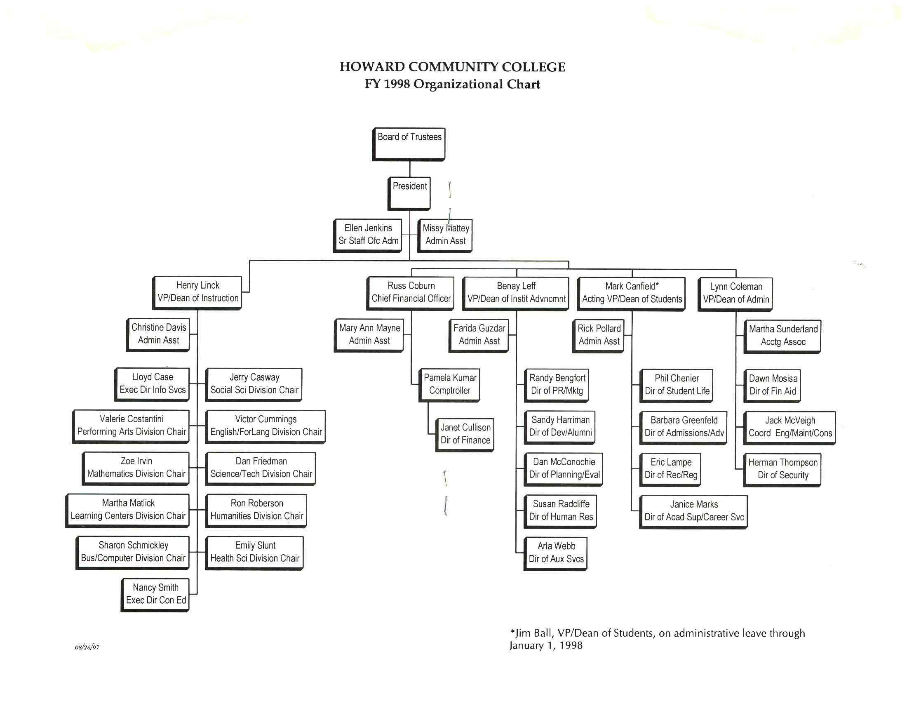

Appendix B
Brochure for Presidential Search

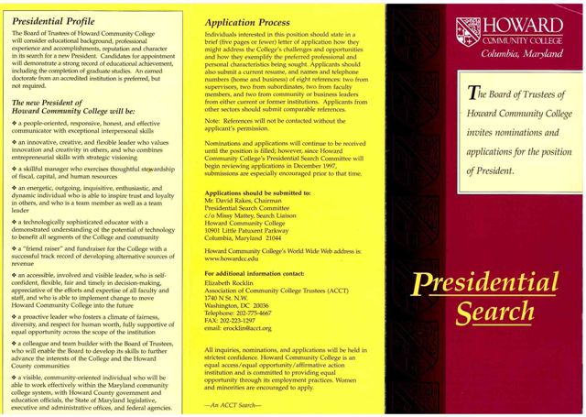

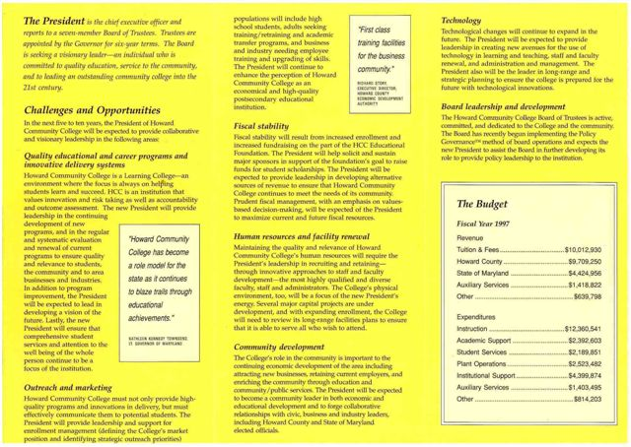
Appendix C
Presidential Transition Team

The Presidential Transition Team had the following representatives. The list shows the areas they represented and their Department or Division:

Pearl Atkinson-Stewart, Administration and Finance (Plant Operations)
Randy Bengfort, Institutional Advancement (Public Relations)
John Bouman, Instruction (Full-time Faculty)
Clarence Carvell, Presidential Search Committee (Business/Community)
Roberta Dillow, Presidential Search Committee (Business/Community)
Barbara Greenfeld, Admissions (Student Services)
Farida Guzdar, Institutional Advancement (Dean of Institutional Advancement Office)
Mike Heinmuller, Information Services (Instruction)
Ethel Hill, Presidential Search Committee (Business/Community)
Shaun Koenig, Student
Theresa Marrow, Student Services
Missy Mattey, President’s Office (Board of Trustees Liaison)
Mary Ann Mayne, Administration and Finance (Business Office)
Rosemarie Presley, Instruction (Division Offices)
Ron Roberson, Instruction (Full-time Faculty)
Robin Saunders, Student Services (Student Activities)
Fred Schoenbrodt, Board of Trustees (Trustee)
Judy Thomas, Instruction (Continuing Education)
Herman Thompson, Administration and Finance (Security)
Patty Turner, Instruction (Full-time Faculty)

Appendix D
HCC Stakeholders as Identified by the Presidential Transition Team

- Students
- Faculty/staff
- Governing/advisory bodies – current
- Governing/advisory bodies – past members
- Alumni
- Donors
- Vendors
- Neighbors
- Arts & cultural groups
- Elected officials – county
- Elected officials – state
- K-12 education community
- Higher education community
- Higher Education Community (outside HCC)
- Ethnic representatives
- Health facilities and organizations
- Business and professional groups
- Service Clubs and fraternal organizations
- Religious organizations
- Nonprofit organizations
- Military and law enforcement
- Media

Appendix E
HCC Fall Full- and Part-time Credit Enrollment: 1998 - 2006
FALL | 1998 | 1999 | 2000 | 2001 | 2002 | 2003 | 2004 | 2005 | 2006
Full Time | 1536 | 1608 | 1815 | 1931 | 2139 | 2273 | 2433 | 2635 | 2773
Part-Time | 3564 | 3644 | 3637 | 4003 | 4043 | 4162 | 4278 | 4206 | 4388
Total Students | 5100 | 5252 | 5452 | 5934 | 6182 | 6435 | 6711 | 6841 | 7161
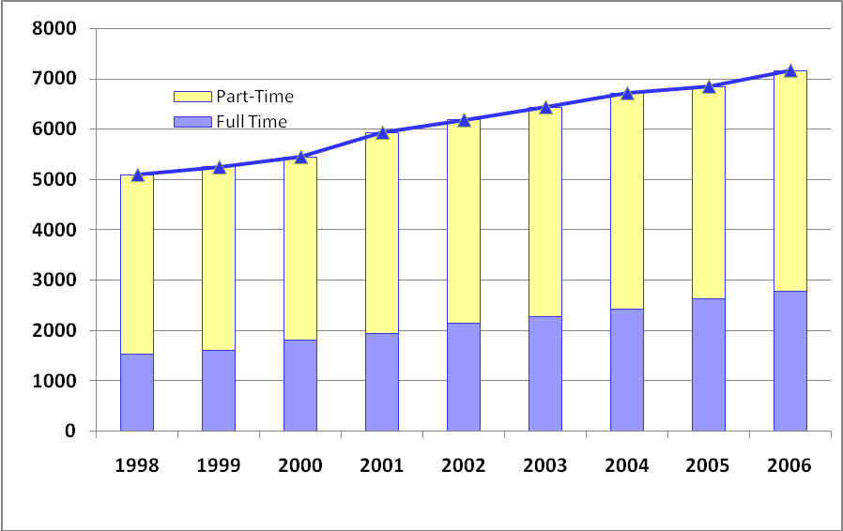

Appendix F
HCC Fall Enrollment by Race
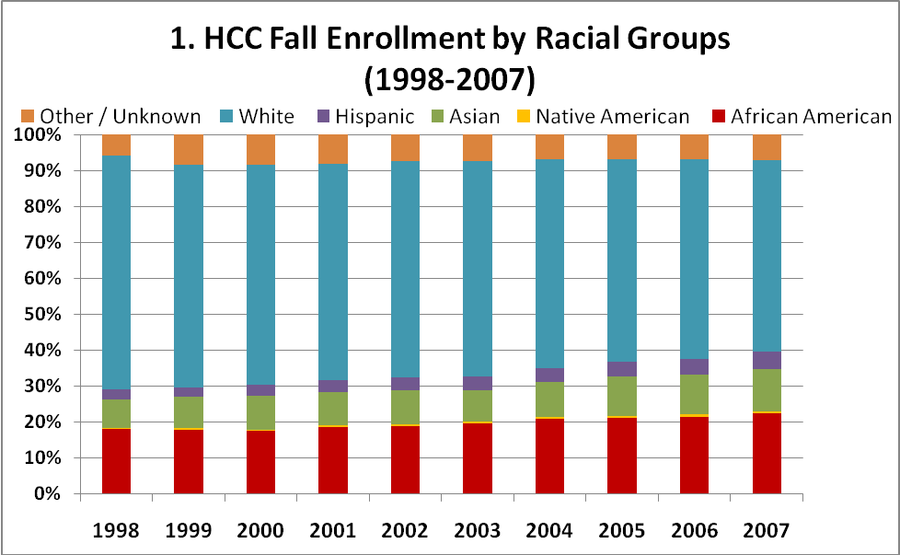
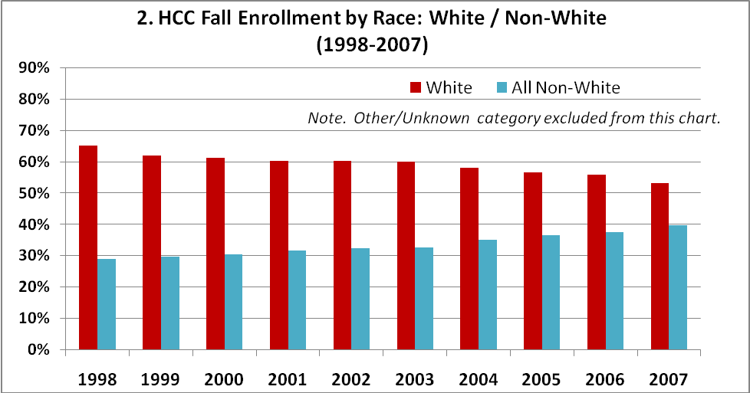

 | HCC Fall to Fall Enrollment by Race (%)
Year | 1998 | 1999 | 2000 | 2001 | 2002 | 2003 | 2004 | 2005 | 2006 | 2007
African American | 17.9% | 17.9% | 17.4% | 18.4% | 18.8% | 19.6% | 20.9% | 21.0% | 21.4% | 22.5%
Native American | 0.4% | 0.4% | 0.4% | 0.6% | 0.5% | 0.4% | 0.3% | 0.5% | 0.6% | 0.5%
Asian | 7.9% | 8.7% | 9.4% | 9.3% | 9.7% | 8.8% | 9.9% | 11.1% | 11.1% | 11.7%
Hispanic | 2.7% | 2.7% | 3.1% | 3.3% | 3.5% | 3.9% | 3.9% | 4.0% | 4.3% | 4.9%
White | 65% | 62% | 61% | 60% | 60% | 60% | 58% | 56% | 56% | 53%
Other / Unknown | 5.9% | 8.4% | 8.3% | 8.1% | 7.5% | 7.4% | 6.9% | 6.9% | 6.8% | 7.2%
Total | 100% | 100% | 100% | 100% | 100% | 100% | 100% | 100% | 100% | 100%
All Non-White | 29.0% | 29.6% | 30.3% | 31.6% | 32.4% | 32.7% | 35.1% | 36.6% | 37.4% | 39.6%

Appendix G
HCC Faculty/Staff by Race
 | 1998 | 1999 | 2000 | 2001 | 2002 | 2003 | 2004 | 2005 | 2006 | 2007
African American | 94 | 100 | 119 | 134 | 133 | 146 | 144 | 167 | 161 | 194
Native American |  |  |  | 1 | 2 | 5 | 2 | 2 | 1 | 2
Asian | 16 | 25 | 26 | 40 | 44 | 58 | 63 | 63 | 63 | 65
Hispanic | 7 | 8 | 11 | 16 | 20 | 16 | 18 | 23 | 24 | 26
White | 407 | 468 | 513 | 634 | 671 | 684 | 717 | 708 | 751 | 777
Other / Unknown | 46 | 92 | 77 | 37 | 30 | 23 | 19 | 29 | 26 | 31
Total | 570 | 693 | 746 | 862 | 900 | 932 | 963 | 992 | 1026 | 1095
All Non-White (excl. Other/Unknown) | 117 | 133 | 156 | 191 | 199 | 225 | 227 | 255 | 249 | 287

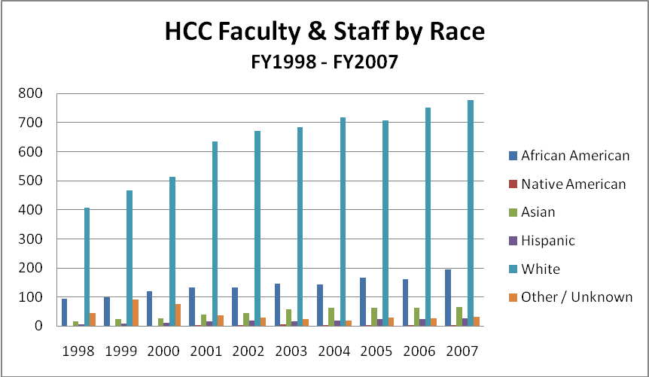
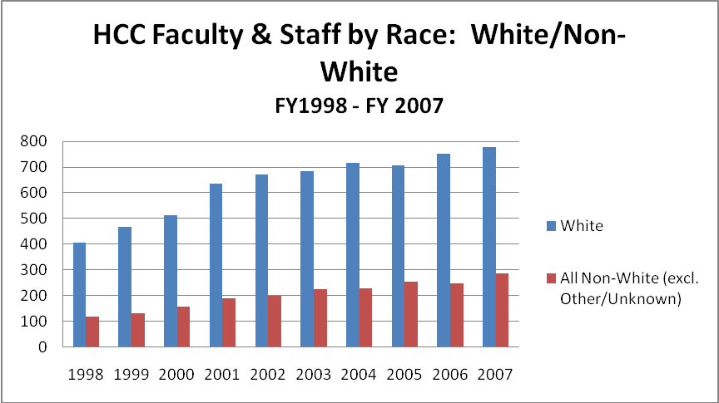
Endnotes

A copy of the brochure announcing the search for a president is found in Appendix B.
The term “President’s Cabinet” was introduced by Burrill to refer to the senior administrators who reported directly to him. This body is now called the President’s Team.
A copy of Burrill’s restructured organization chart is found in Appendix A.
The joint title of Vice President/Dean was still used up to 1998.
A list of the Presidential Transition Team is in Appendix C.
Carlson’s membership on the Board would end on June 30, 1998 and his place would be taken by Delroy L. Cornick.
Duncan’s own words were, “it was a tough year. It was a year that I was exhausted all the time. It was very stressful … there was a great deal of tension all the time.” In another part of Madaras’ interview of August 22, 2003, Duncan was even more direct in describing the tension.
All of this Dreier history is basically paraphrased from information that has been generously and graciously provided by Valerie Lash, Chair of the Fine and Performing Arts Division.
These data are based on HCC’s Databook statistics for fiscal years 1999 and 2000.
The price of the trip was calculated at actual anticipated expenses plus an “overhead” that would be used for contribution to the college’s George Livieratos Memorial Endowment Scholarship. Community residents going on the trip were told of this ‘up front.”
Weekend classes began on Saturday, August 25.
A student standing next to the author, after being transfixed by what he saw, stated in a monotone but shocked voice that this could only happen in a science fiction movie.
As of the writing of this volume, there was no precise information on what was put into the time capsule. Most staff who were asked speculated that the contents of the capsule probably contained an HCC catalog, schedule of classes, some CD’s, and possibly examples of attire worn by younger students.
The reader may wish to refer to Volume I of HCC’s history for more detail and Schoenbrodt’s role in the college’s creation, since he was on the county’s Board of Education during the early planning days and was the founding Chairman of HCC’s first Board of Trustees.
Hetherington had been appointed Executive Vice President in June 2005. She also was in charge of Student Services.
The author attended the meeting and the data on the various individuals and groups that testified comes from the author’s handwritten notes.
Up to fall 1998, Information Services was under the Vice President/Dean of Instruction; however, given Burrill’s interest in technology and some of the projects of the Information Systems Office the Executive Director of Information Services really reported directly to the president.
V. Marinich interview with Joan Athen, March 28, 2010, p.12.
V. Marinich telephone conversation with Benay Leff,
V. Marinich interview with Joan Athen, March 28, 2010, p.13.
D. Burrill memo to “College Community,” July 10, 1997.
V. Marinich interview with Joan Athen, March 28, 2010, p. 8.
Howard Community College Board of Trustees Minutes, September 24, 1997, p.4.
Howard Community College Board of Trustees Minutes, December 17, 1997, p.3.
Barbara Kellner. Images of America: Columbia. Arcadia Publ. Co., 2005, p.75.
Howard Community College Board of Trustees Minutes, January 28, 1998, p.2.
Howard Community Board of Trustees. Unnumbered Discussion Item, December 17, 1997.
Randy Bengfort, Memorandum, “Presidential Transition Team: Final Report,” June 10, 1998.
Randy Bengfort Email to “Everyone,” February 2, 1998, and Baltimore Sun, February 5, 1998.
Idem.
Randy Bengfort, Memorandum, “Presidential Transition Team: Final Report,” June 10, 1998.
B. Greenfeld E-mail to V. Marinich, June 8, 1998.
V. Marinich interview with M.E.Duncan, May 25, 2008, p. 14.
Howard Community College, “Strategic Vision for the 21st Century,” April, 1999, p.5.
Ibid., pp. 37-40.
V. Marinich interview with M.E.Duncan, May 25, 2008, p. 14.
L. Madaras interview with M.E.Duncan, August 22, 2003, p.4.
Ibid. p.7.
On the QT. Vol. 4, Issue 1, Winter, 1998, p.3.
Idem.
L. Madaras, interview with M.E.Duncan, August 22, 2003, p.4.
HCC Website, April, 2011.
Idem.
Howard Community College. Alumni News. Spring, 2000, p.1.
Office of Admissions, undated Immigration Status Report, p.1.
Maryland Department of Planning, Planning Data Services, March, 2006.
HCC’s Office of Admissions undated Report.
Howard Community College, Alumni News, Fall, 2000, p. 5.
Howard Community College, Alumni News, Spring, 2001, p. 3.
Idem.
Howardcc.edu/Faculty_Resources/TeachingResources/fye/History-Philosophy.html.
Laurel College Center Website, May, 2011.
The Baltimore Sun, April 26, 2001.
Telephone message from Neetika Sharma to V. Marinich, June 8, 2011.
Columbia Flier. “HCC Recruiters Extend Hand to South Korea.” January 2, 2003.
Howard Community College Board of Trustees Work Session, Item I-D, November 20, 2002.
The Times of Howard Community College. “ILB Open for Business,” Vol. XXII, No.1, p.1.
Howard Community College. Alumni News, Spring, 2003, p.1.
The Sun in Howard. Wednesday, September 24, 2003, p.3B.
Memorandum of Understanding between HCCAAC and HCC, March 30, 2006.
The HCC Experience. Alumni & Friends Newsletter, December 2003, p.4.
The Times of Howard Community College. March 28, 2003, p.2.
Idem.
The Sun in Howard County. Thursday, April 17, 2003, p.4B.
The Times of Howard Community College. Vol. XXXIII, No. VII, December, 2003, p.1.
Idem.
Howard County Times, September 11, 2003 (newspaper clipping did not show page number).
The Washington Examiner. “O’Malley Applauds HCC’s Citistats Program,” March 6, 2007.
This quote is from HCC’s website announcing the December 3, 2007 award to Step Up by the National Council of Instructional Administrators.
The HCC Experience. Alumni & Friends Newsletter, December, 2003, p.13.
Grand Prix Income Event Year 1988-2008. Updated 10/01/07 by M. Mattey.
Howard Sun, “Belmont Sold to Maryland, Science Club,” July 14, 1982.
“Endangered Elkridge, Part II: Belmont. http://Elkridge.patch.com.
The Howard County Times. “Neighbors Squawk on Road to Inn,” June 10, 1982, p.4.
Smithsonian Institution. Memorandum for the record, September 8, 1980.
The Howard County Times. “Neighbors Squawk on Road to Inn,” June 10, 1982, p.4.
The Sun. “Maryland weighing purchase of historic Belmont Manor,” September 1, 1980.
Howard Sun, “Belmont Sold to Maryland, Science Club,” July 14, 1982.
Deed of Sale between Smithsonian Institution and The American Chemical Society, September 9, 1983.
The Viaduct. “Belmont Conference Center On the Market,” Vol. 17, No.3, June-July 2004, p.1.
Howard Community College Educational Foundation. Finance & Investment/Executive Committee Meeting Minutes, May 25, 2004, p.2.
Howard Community College Educational Foundation. Full Board Meeting Minutes, June 15, 2004, p. 1.
Howard Community College Educational Foundation. Full Board Meeting Minutes, September 14, 2004, p.2.
Howard Community College Educational Foundation. Executive/Finance & Investment Committee (sic) Minutes, November 30, 2004.
Howard Community College Educational Foundation. Board of Director’s (sic) Meeting, September 13, 2005, p.2.
The Howard Sun, November 21, 2004, p.9a.
Alumni and Friends Newsletter. The HCC Experience. February, 2006, p. 14.
www.nist.gov/baldridge/publications/criteria.cfm.
Howard Community College. Board of Trustees Retreat Notes, June 9, 2005, p.1.
Columbia Flier. The news clipping was not dated, but it was @ December, 2006.
Howard Community College 2006 Annual Report to the Community, p.7.
The Baltimore Sun, “School Leader Steps Down,” February 20, 2007.
The Baltimore Sun, March 28, 2007.

